### **1. Introduction**

This project outlines the Entity-Relationship (ER) schema for an online platform that manages book publication, sales, and customer interactions. It supports functionalities like multi-author publications, multiple editions, order tracking, and wishlist management.

### **2. ER Diagram**

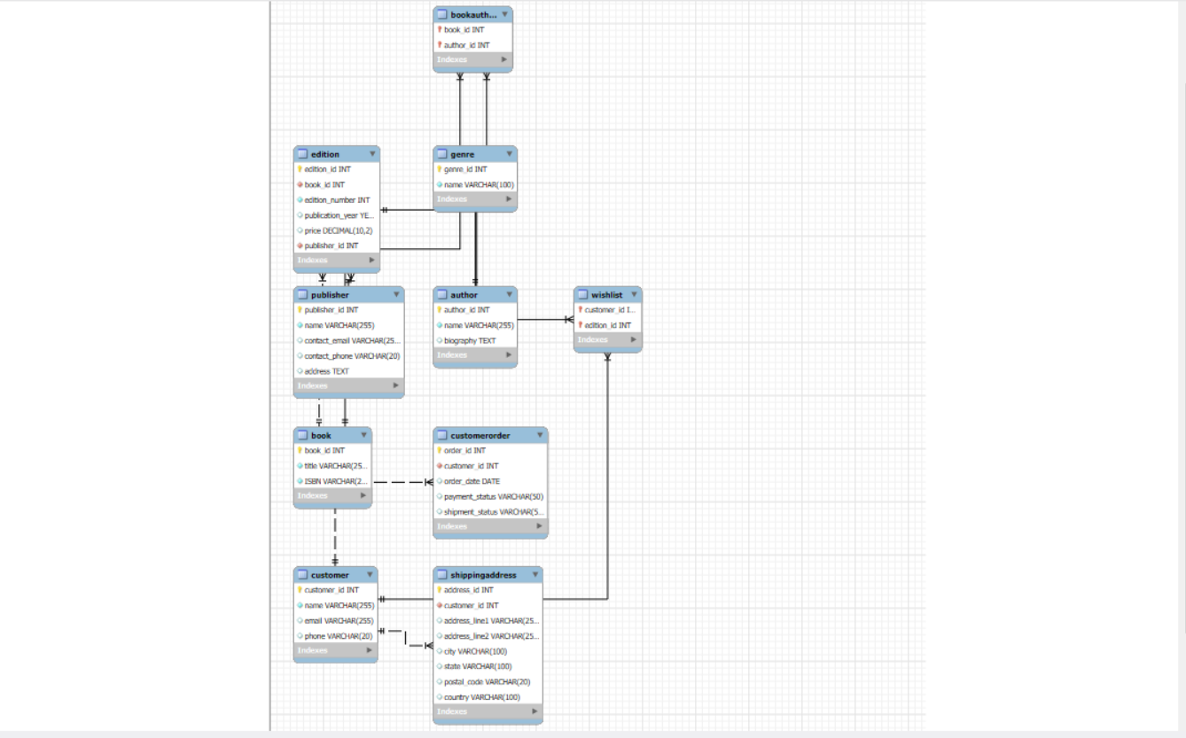

### **3. Entities and Attributes**

#### **◾ Book**

* **book_id** (PK)
* **title**
* **ISBN**

#### **◾ Edition**

* **edition_id** (PK)
* **book_id** (FK)
* **edition_number**
* **publication_year**
* **price**
* **publisher_id** (FK)

#### **◾ Publisher**

* **publisher_id** (PK)
* **name**
* **contact_email**
* **contact_phone**
* **address**

#### **◾ Author**

* **author_id** (PK)
* **name**
* **biography**

#### **◾ Genre**

* **genre_id** (PK)
* **name**

#### **◾ Customer**

* **customer_id** (PK)
* **name**
* **email**
* **phone**

#### **◾ ShippingAddress**

* **address_id** (PK)
* **customer_id** (FK)
* **address_line1, address_line2**
* **city, state, postal_code, country**

#### **◾ CustomerOrder**

* **order_id** (PK)
* **customer_id** (FK)
* **order_date**
* **payment_status**
* **shipment_status**

#### **◾ OrderItem *(not shown but logically required)***

* **order_id** (FK)
* **edition_id** (FK)
* **quantity**
* **item_discount**

#### **◾ Wishlist**

* **customer_id** (FK)
* **edition_id** (FK)

#### **◾ BookAuthor**

* **book_id** (FK)
* **author_id** (FK)

#### **◾ BookGenre**

* **book_id** (FK)
* **genre_id** (FK)

### **4. Relationships Summary**

| **Relationship** | **Type** | **Link Table** |
| --- | --- | --- |
| Book – Author | Many-to-Many | BookAuthor |
| Book – Genre | Many-to-Many | BookGenre |
| Book – Edition | One-to-Many | Book → Edition |
| Edition – Publisher | Many-to-One | Edition → Publisher |
| Customer – Address | One-to-Many | Customer → ShippingAddress |
| Customer – Order | One-to-Many | Customer → CustomerOrder |
| Order – OrderItem | One-to-Many | CustomerOrder → OrderItem |
| Edition – OrderItem | One-to-Many | Edition → OrderItem |
| Customer – Wishlist | Many-to-Many | Wishlist |

### **5. Special Scenarios Handled**

* **Co-Authored Books**: Through BookAuthor M:N
* **Multiple Genres**: Through BookGenre M:N
* **Multiple Editions**: Separate Edition table with price/year
* **Order Details**: Via OrderItem table
* **Wishlist Functionality**: Through Wishlist table
* **Pre-orders**: Can be flagged by status or release date